#### Using Detail Containers

In Revit: From the Insert tab, click on Insert from File > Insert Views from File:

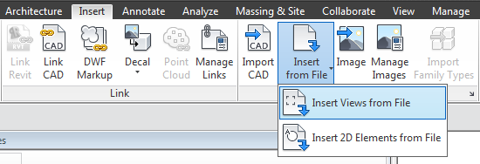

Figure 2.6‑1 Insert Views from Container Files

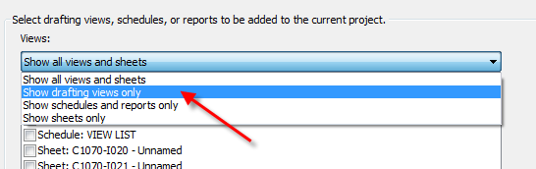

Figure 2.6‑2 Show Drafting Views Only

Select one of the container files. Navigate to the appropriate detail container file. When the Insert Views dialog box appears, the default setting is to show all views and sheets that can be inserted:

“Views” list and change it to “Show Drafting Views Only”.

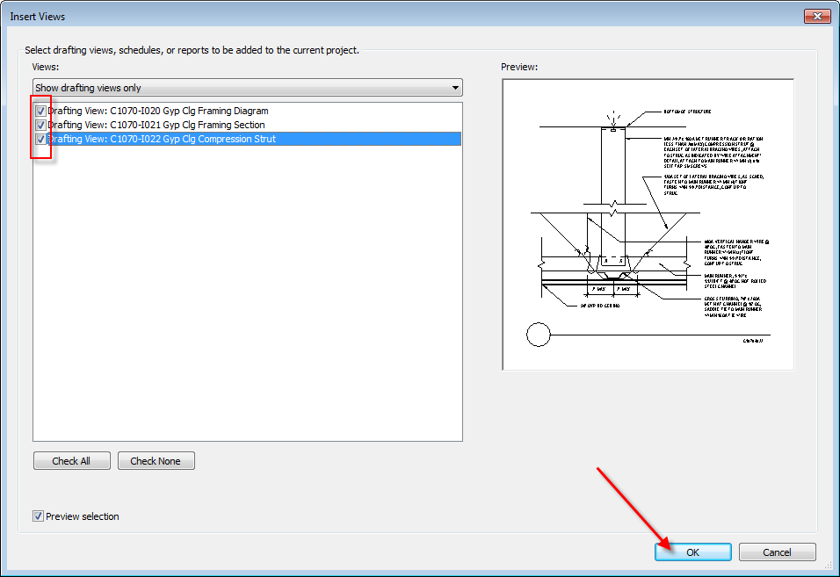

Figure 2.6‑3 Click OK

Select the drafting views you'd like to insert and then click “OK”: